|  |  |  |  |
| --- | --- | --- | --- |
| Input Function (Insert) Input(ID/Name/Major)  Input(Grade/Credits) | Expected Output | Actual Output | Pass/Fail |
| Insert  101/Josh/Software | Success Window  Josh/Software/4.0 | Success Window  Josh/Software/4.0 | Pass |
| Insert  102/Dave/Hardware | Success Window  Dave/Hardware/4.0 | Success Window  Dave/Hardware/4.0 | Pass |
| Insert  101/Should/Fail | Failure Window (duplicate ID) | Failure Window (duplicate ID) | Pass |
| Insert  <E>/<E>/<E> | Failure Window  (Blank ID) | Failure Window  (Blank ID) | Pass |
| Find  101 | Success  Josh/Software/4.0 | Success  Josh/Software/4.0 | Pass |
| Find  102 | Success  Dave/Hardware/4.0 | Success  Dave/Hardware/4.0 | Pass |
| Find  103 | Failure (Student not Found) | Failure (Student not Found) | Pass |
| Update  101  A/3 | Success  Josh/Software/4.0 | Success  Josh/Software/4.0 | Pass |
| Update  101  F/3 | Success  Josh/Software/2.0 | Success  Josh/Software/2.0 | Pass |
| Update  103 | Failure (Student Not Found) | Failure (Student Not Found) | Pass |
| Delete  101 | Success  Josh/Software/2.0  Removed from Database | Success  Josh/Software/2.0  Removed from Database | Pass |
| Find  101 | Failure (Student Not Found) | Failure (Student Not Found) | Pass |
| Find  102 | Success  Dave/Hardware/4.0 | Success  Dave/Hardware/4.0 | Pass |

Input and Output test cases

Screenshots of Test Cases

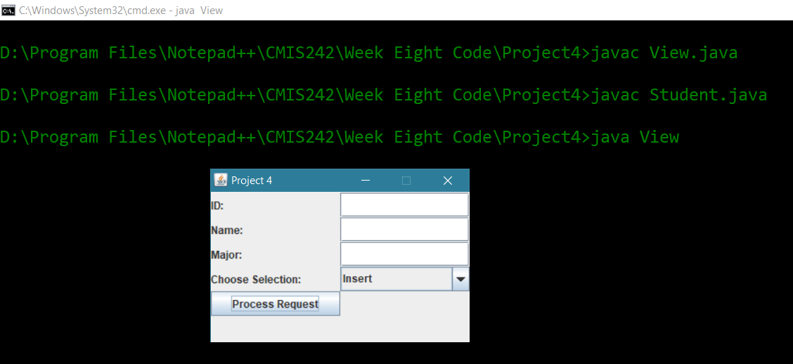

All files compiled and run

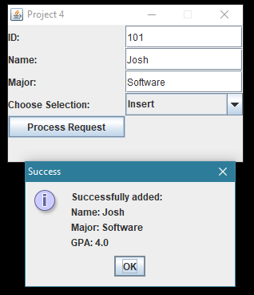

Add Student 101

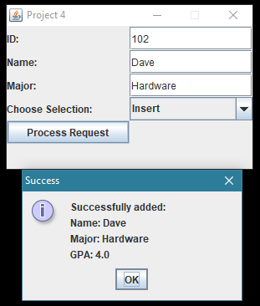

Add Student 102

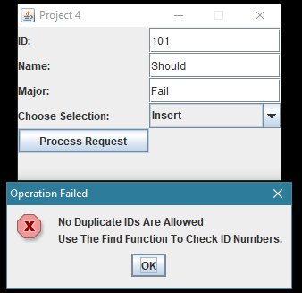

Attempt to add student 101 again, no duplicates allowed in hashmap

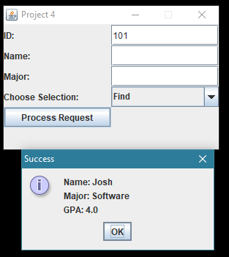

Display student 101 record

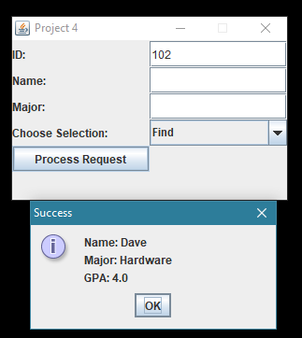

Display student 102 record

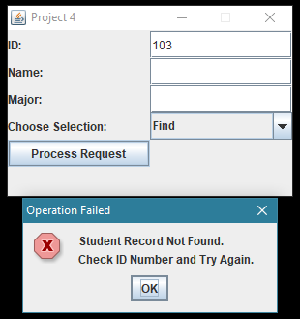

Search for student 103, student is not found

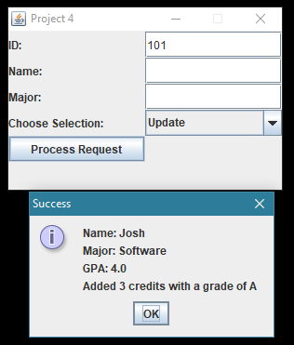

Add 3 credits of 4 points to student 101

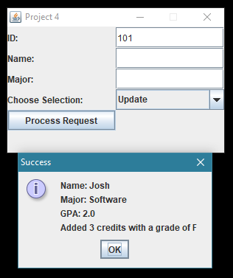

Add three credits of 0 points to student 101

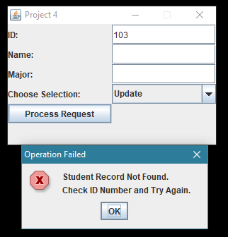

Attempt to update student 103, student not found

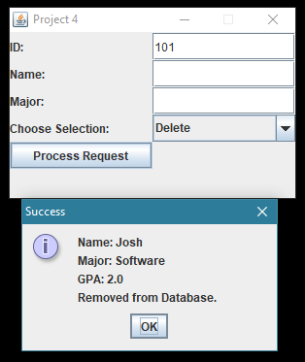

Delete student 101

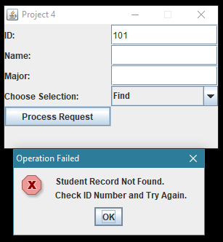

Search for student 101, student not found

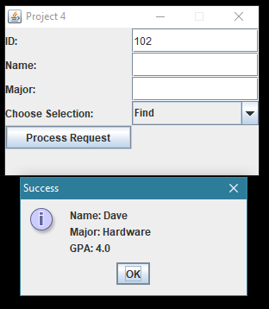

Search student 102 which is still in the HashMap